Join us for a screening of The Sentence
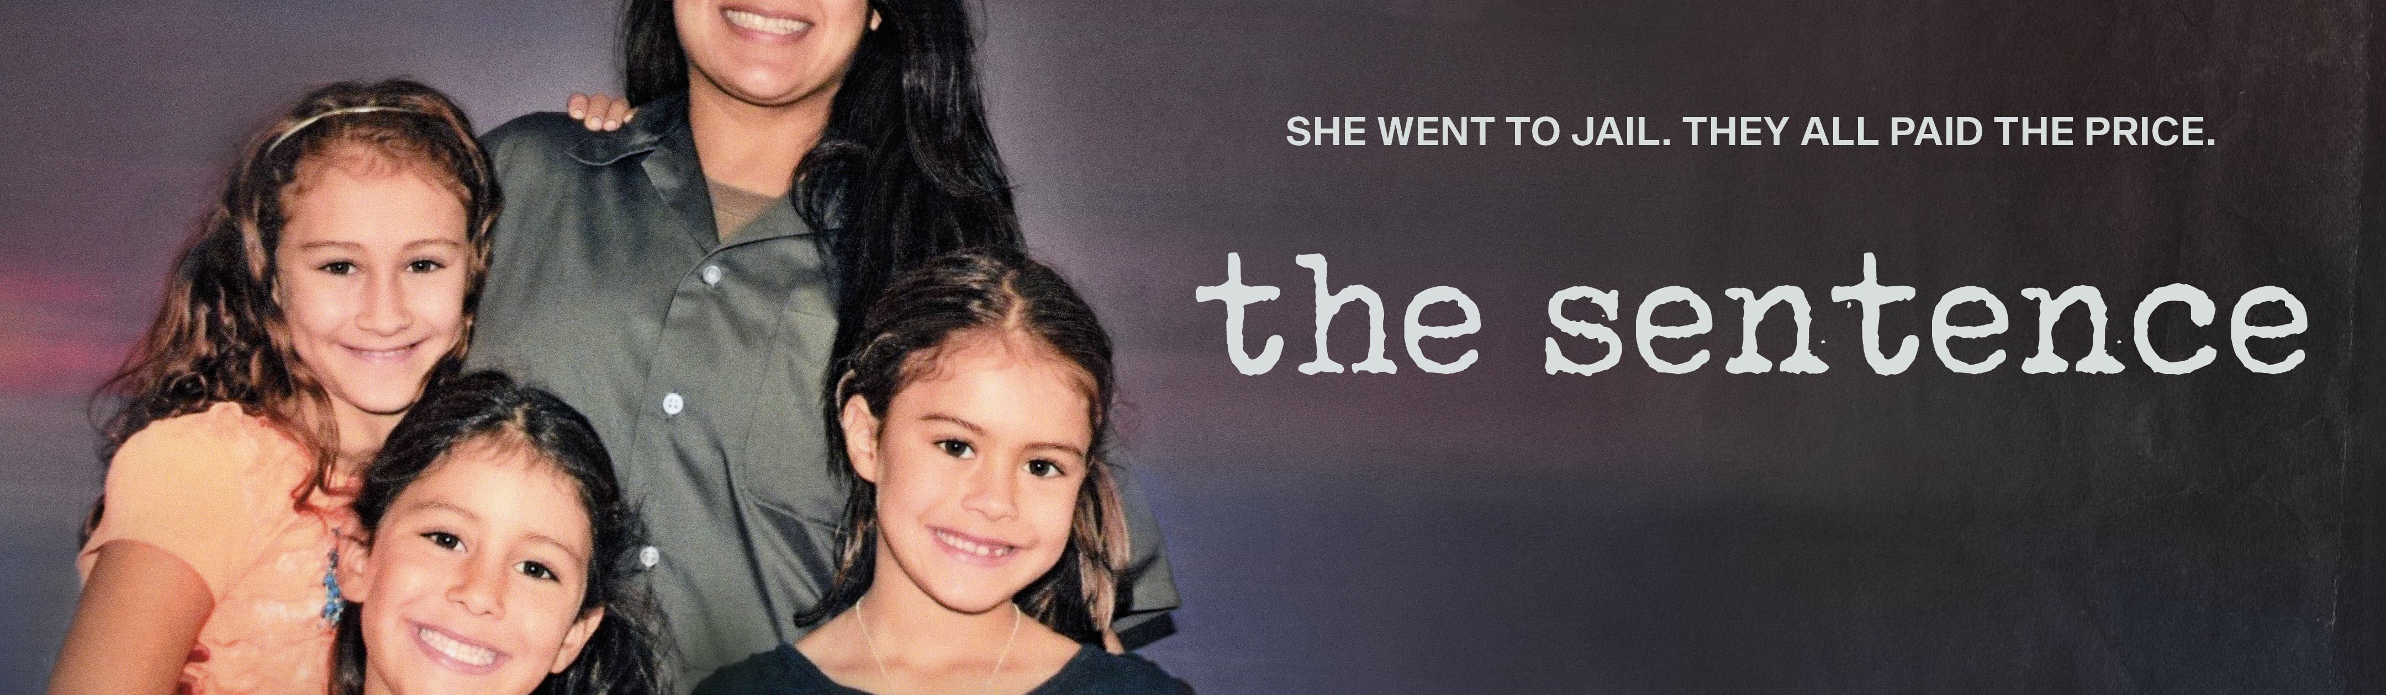
Presented by [YOUR ORGANIZATION HERE]
___________________________________________________________________________

The Sentence explores the story of Cindy Shank, a mother of three young children
serving a 15-year sentence in federal prison for her tangential involvement in a
Michigan drug ring years before. A lyrical, intimate story documented over 10 years
by Cindy’s younger brother, filmmaker Rudy Valdez, The Sentence follows Cindy’s
struggles to be present in her children’s lives from behind bars and her daughters’
experiences growing up without their mother at home, while her husband, parents
and siblings fight for her release before the last months of the Obama
administration’s Clemency Project. After winning the 2018 Audience Award at the
Sundance Film Festival The Sentence was acquired by HBO and went on to win a
Primetime Emmy for Exceptional Merit in Documentary Filmmaking.
___________________________________________________________________
The Sentence
A documentary by Rude Valdez
Followed by a (discussion, panel discussion, Q&A, etc.)
When: [INSERT HERE]
Where: [INSERT HERE]
Directions: [INSERT HERE]
RSVP and Contact: [INSERT HERE]

