Join us for a screening of Trapped: Cash Bail in America
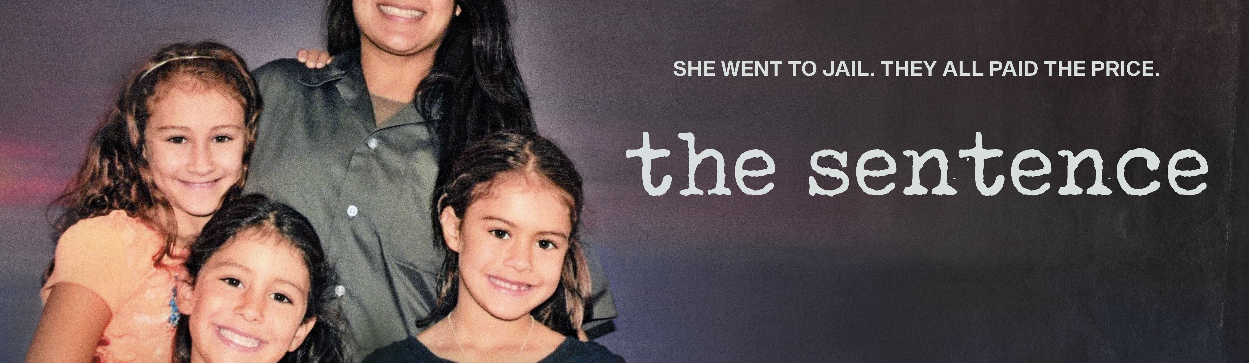
Presented by [YOUR ORGANIZATION HERE]
_______________________________________________________________________

Every year, millions of Americans are incarcerated before even being convicted of a crime – all because they can’t afford to post bail. How did we get here? “Trapped: Cash Bail in America” shines a light on our deeply flawed criminal justice system and the activists working to reform it. This new documentary explores the growing movement to end the inherent economic and racial inequalities while highlighting victims impacted by an unjust system, the tireless campaigners fighting for criminal justice reform, and a bail industry lobbying to maintain the status quo. “Trapped: Cash Bail in America” is produced and written by Chris L. Jenkins and edited and directed by Garrett Hubbard.
___________________________________________________________________

Trapped: Cash Bail in America
Followed by a (discussion, panel discussion, Q&A, etc.)
When: [INSERT HERE]
Where: [INSERT HERE]
Directions: [INSERT HERE]
RSVP and Contact: [INSERT HERE]

