Join us for a screening of
DESCENDED FROM THE PROMISED LAND: THE LEGACY OF BLACK WALL STREET
Presented by [YOUR ORGANIZATION HERE]

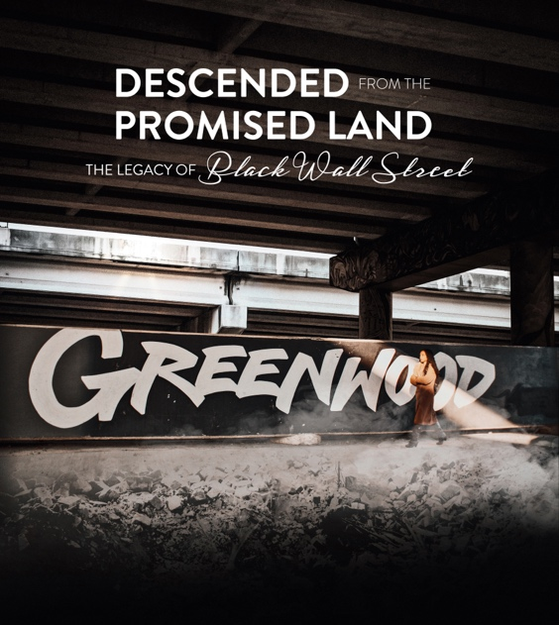

In 1921, North Tulsa’s Greenwood District, the most prosperous Black community in America, was set ablaze, bombed, and looted during a racially motivated violent attack against the thriving Black community. Businesses, homes, and lives were lost, and Black Wall Street, as it was known, has never reclaimed its former glory. The Tulsa Race Massacre was only the first in a line of repeated targeted attacks on the progress of the Greenwood District and its residents.

Through the lens of Black Wall Street descendants Byron Crenshaw, Jacqueline Blocker and Michelle Blocker, we draw a century-long thread from the Tulsa Race Massacre to the present, exploring the lingering economic, psychological and emotional impacts that have undermined the rebuilding of the once thriving community.

Descended from The Promised Land: The Legacy of Black Wall Street

A documentary film by Nailah Jefferson

Followed by a (discussion, panel discussion, Q&A, etc.)

When: [INSERT HERE]

Where: [INSERT HERE]

Directions: [INSERT HERE]

RSVP and Contact: [INSERT HERE]

